BACKGROUND

From our original NBA Salary Prediction project, we were able to look at five different models in order to determine the best performing for our particular dataset. These are the models we considered:

1. Ordinary Least Squares (OLS)
2. Ridge Regression (RR)
3. Lasso Regression (LR)
4. ElasticNet Regression (ENR)
5. Extreme Gradient Boosting Regression (XGBR)

Table 1 shows the R2 and root mean square error (RMSE) values for each model fit. As clearly indicated, the first four models had very similar results. The XGBR model performed significantly better and that is the model we chose as the bet fitting model for our original project and it is the model we are using for this effort.

Table 1. Model Results Summary from Original Project

|  |  |  |
| --- | --- | --- |
| Model | R2 | RMSE |
| OLS | 0.63 | 4398500 |
| RR | 0.63 | 4398502 |
| LR | 0.63 | 4398500 |
| ENR | 0.62 | 4432638 |
| XGBR | 0.92 | 1818766 |

GENERALIZATION

We followed a very similar procedure for this project as we did in the original effort. Here is a breakdown of the particular steps we took to prepare the data for the model and the model results for each year considered.

* **Loading the data**—the data were loaded into a Jupyter Notebook directly from a CSV file that was generated from the scraped data script. The resultant dataframe consisted of 3638 rows and 50 columns of data.
* **Formatting the data**—the scraped data had different column headers than what we needed for our model, so the next step was to change all of the column headings.

Next, since we were interested in salary predictions based on year, we needed to separate the dataframe by year. This gave us 10 separate dataframes for the years 2010 through 2019.

We then needed to separate the individual dataframes into a features and labels dataframe. The labels dataframes consisted only of the Salary columns, while the features dataframes contained all of the other variables.

The next step involved reducing the features to only the variable we were interested in. These were determined in our original project after an extensive features selection process. The final variables that are considered for this model are:

* + Age, Player Efficiency Rating, Blocks, Turnover Percentage, Steals, Assists Percentage, Games Started, Games Played, Total Rebounds, Field Goals, Defensive Box Plus Minus, Defensive Rebound Percentage, Usage Percentage, and Free Throws.

The last step involved normalizing all of the data except the Salary column. This was done to change the values of the numeric columns to a common scale, without distorting differences in the ranges of values.

* **Running the model**—the model was run 10 separate times. One for each year range. The results of the model runs are shown in Table 2.

Table 2. Summary of Yearly Model Performance

|  |  |  |
| --- | --- | --- |
| Year | R2 | RMSE |
| 2010 | 0.946 | 1099627 |
| 2011 | 0.949 | 1070874 |
| 2012 | 0.957 | 989,150 |
| 2013 | 0.942 | 1132491 |
| 2014 | 0.946 | 1174769 |
| 2015 | 0.940 | 1204874 |
| 2016 | 0.955 | 1147450 |
| 2017 | 0.940 | 1641827 |
| 2018 | 0.926 | 2124853 |
| 2019 | 0.923 | 2246051 |

* **Plotting the Top 10 overpaid and underpaid players**—once the model predictions were complete, we made a plot of the 10 most overpaid and 10 most underpaid players based on their performance statistics. Figures 1 and 2 show those plots for the 2019 year.

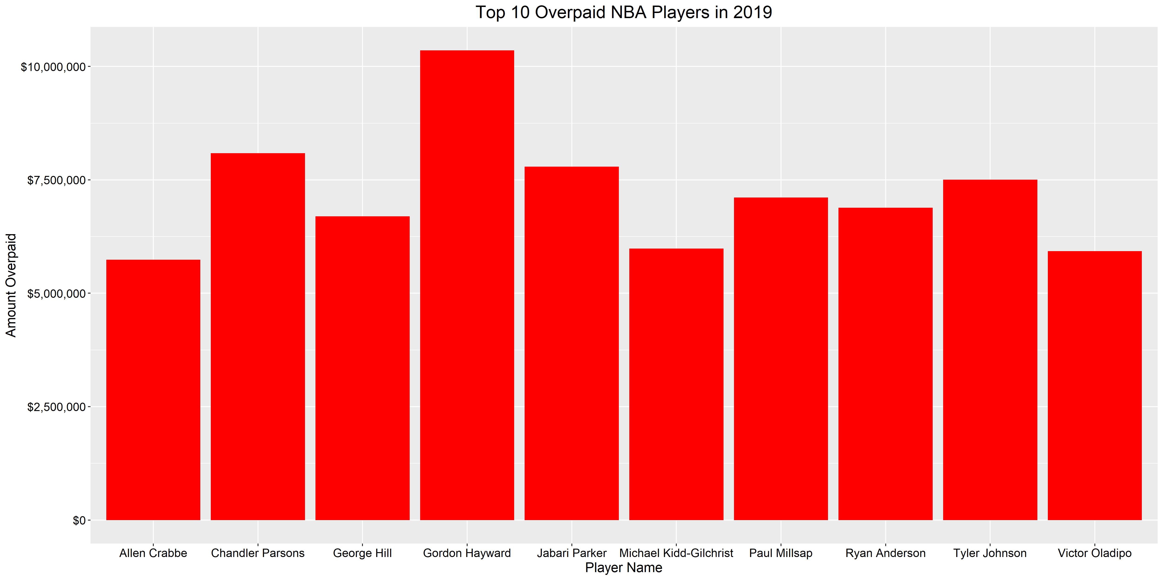

Figure 1. Ten Most Overpaid Players in 2019

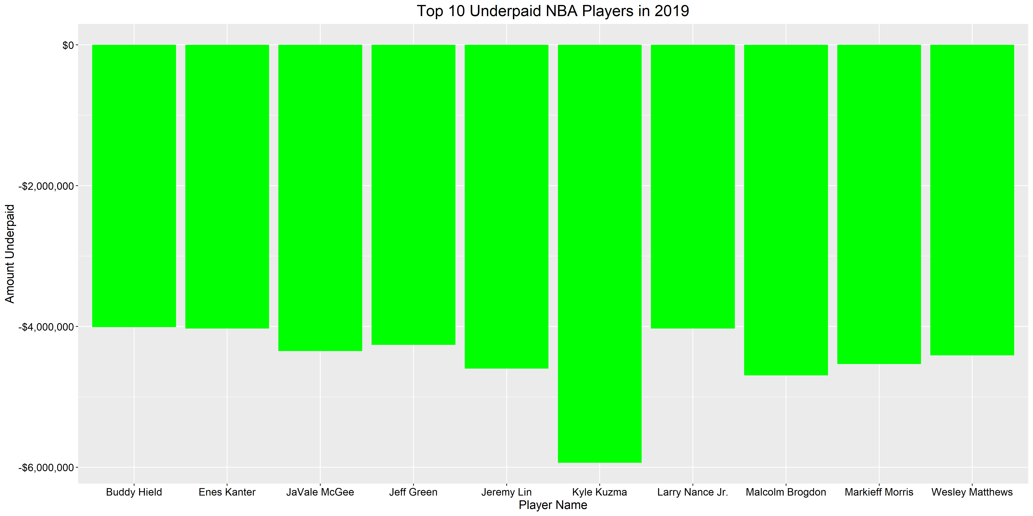

Figure 2. 10 Most Underpaid Players in 2019

CONCLUSIONS

The XGBR model provided excellent generalization to our new datasets. The R2 values were high and the RMSE values were considerably lower than what we saw with the original four models shown in Table 1. One trend we did start to notice was that the model seems to be decreasing in performance in the last four years. The R2 values are decreasing and the RMSE values are increasing. We are not sure at this point what is causing this, but it is an interesting trend and it grabbed our attention.